Chapter 21
Optimum Currency Areas
and the Euro

■ Chapter Organization
How the European Single Currency Evolved.
What Has Driven European Monetary Cooperation?
Box: Brexit.
The European Monetary System, 1979–1998.
German Monetary Dominance and the Credibility Theory of the EMS.
Market Integration Initiatives.
European Economic and Monetary Union.
The Euro and Economic Policy in the Euro Zone.
The Maastricht Convergence Criteria and the Stability and Growth Pact.
The European Central Bank and the Eurosystem.
The Revised Exchange Rate Mechanism.
The Theory of Optimum Currency Areas.
Economic Integration and the Benefits of a Fixed Exchange Rate Area: The GG Schedule.
Economic Integration and the Costs of a Fixed Exchange Rate Area: The LL Schedule.
The Decision to Join a Currency Area: Putting the GG and LL Schedules Together.
What Is an Optimum Currency Area?
Other Important Considerations.
Case Study: Is Europe an Optimum Currency Area?
The Euro Crisis and the Future of EMU.
Origins of the Crisis.
Self-Fulfilling Government Default and the “Doom Loop.”
A Broader Crisis and Policy Responses.
ECB Outright Monetary Transactions.
Response to the COVID-19 Pandemic
The Future of EMU.

Summary

■ Chapter Overview
The establishment of a common European currency and the debate over its possible benefits and costs was one of the key economic topics of the 1990s. Students should be familiar with the euro but probably not with its technical aspects or its history. This chapter provides them with the historical and institutional background needed to understand this issue. It also introduces the idea of an optimum currency area and presents an analytical framework for understanding this concept.
The discussion in this chapter points out that European monetary integration has been an ongoing process. Fixed exchange rates in Europe were a by-product of the Bretton Woods system. When strains began to appear in the Bretton Woods system, concerns arose about the effects of widely fluctuating exchange rates between European countries. The 1971 Werner Report called for the eventual goal of fixed exchange rates in Europe. Reasons for this included enhancing Europe’s role in the world monetary system, declining confidence that the United States would place its international monetary responsibilities ahead of national interests, and turning the European Union into a truly unified market. Also, many Europeans hoped economic unification would encourage political unification and prevent a repeat of Europe’s war-torn history.
The first attempt at a post-Bretton Woods fixed exchange rate system in Europe was the “Snake.” This effort was limited in its membership and placed too high a burden of adjustment on countries with weak currencies. The European Monetary System (EMS), established in 1979, was more successful. The original member countries of the EMS included Germany, France, Italy, Belgium, Denmark, Luxembourg, the Netherlands, and Ireland. In later years, the roll of membership grew to include Spain, Great Britain, and Portugal. The EMS fixed exchange rates around a central parity. Most currencies were allowed to fluctuate above or below their central rate by 2.5%, although the original band for the Italian lira and the bands for the Spanish peseta and the Portuguese escudo allowed for fluctuations of 6% in either direction from the central parity.
After attacks and realignments in its early years, the EMS grew to become sturdier than its predecessors. The presence of small bands instead of pure fixed rates helped, as did the guarantee of credit from strong to weak currency countries. The EMS was, in some sense, simply a peg to the DM. Many felt that the dominant position of the DM had allowed other countries to import Germany’s inflation fighting credibility and that this was another advantage of fixed rates in Europe.
A key component of the EMS was the presence of capital controls. However, limits on capital mobility were counter to a unified European market. Starting in 1987, capital controls were gradually phased out. The removal of these controls contributed to the EMS crisis of 1992–1993. German reunification had led to higher interest rates in Germany (to fight inflationary pressures), but other countries were not in a position to follow the rate hikes. Fierce attacks followed, and some countries (the United Kingdom and Italy) left the EMS in 1992, and the bands were widened to 15% in August 1993.
In 1986, the European Union launched a more aggressive integration package known as “1992” that was intended to complete the internal market by 1992. To further that goal, a plan of the European Economic and Monetary Union, which involved a single currency and was embodied in the Maastricht Treaty, was begun, and by 1993 had been accepted by all EU countries. Reasons for pursuing a single currency included furthering market integration, broadening the viewpoint of monetary policy by moving decision making from the Bundesbank to a European Central Bank, avoiding the difficulties in maintaining fixed rates with free capital movements, and supporting political unification.
A crucial aspect of EMU has been the goal of economic convergence embodied in the Maastricht convergence criteria and the Stability and Growth Pact (SGP). These agreements stipulate low deficits and debt-to-GDP ratios and are an attempt by low-inflation countries to prevent free-spending counterparts from turning the euro into a weak currency. Eleven nations participated in the launch of the euro in 1999, with the United Kingdom and Denmark choosing not to join, Sweden failing the exchange rate stability criteria, and Greece failing all criteria (Greece joined two years later). The nations in the euro area have ceded monetary control to the Eurosystem, comprised of the European Central Bank (ECB) plus the 19 (at press!) national central banks of the euro area. The national central banks are now part of an overarching structure headed by the governing council of the ECB. The ECB is a very independent central bank with no political control and little accountability. In addition, a new exchange rate mechanism has begun in which non-euro EU members peg to the euro.
There are both advantages and drawbacks to this decision to form a common currency union. The theory of optimum currency areas provides a way to frame an analysis of the benefits and costs of a single currency. The benefits of a common currency are the monetary efficiency gains realized when trade and payments are not subject to devaluation risk. These benefits rise with an increase in the amount of trade or factor flows, that is, with the extent of economic integration. A common currency also forces countries to give up their independence with regards to monetary policy (at least those countries that are not at the “center” of the system). This may lead to greater macroeconomic instability, although the instability is reduced the more integrated the country is with the other members of the common currency area. The analyses of the benefits and costs of membership in a common currency area are presented in the text chapter as the GG and LL schedules, respectively. The GG-LL framework is applied to the question of whether Europe is an optimum currency area.
An illuminating way to frame the question is to compare the United States to Europe. The evidence that Europe is an optimum currency area is much weaker than the evidence supporting the notion that the United States is an optimum currency area. Trade among regions in the United States is much higher than trade among European countries. Labor is much more mobile within the United States than within Europe. This is significant as capital mobility has increased, suggesting that a country hit with a negative economic shock may actually experience worse unemployment given that capital will flow to other countries, while labor does not. Furthermore, federal transfers and changes in federal tax payments provide a much bigger cushion to region-specific shocks in the United States than do analogous EC revenues and expenditures, which have no clear mechanism for fiscal federalism. Finally, there are greater differences in factor endowments in Europe, which may promote greater regional specialization to take advantage of economies of scale. Such regional specialization increases the possibility of asymmetric shocks that a common monetary policy has difficulty dealing with.
The chapter then considers the future of the EMU. The facts that the European Union is probably not an optimum currency area, that economic union is so far in front of political union, that EU labor markets are very rigid, and that the SGP constrains fiscal policies will all present challenges to Europe’s economy and to its policy makers in the years ahead. Additional challenges will be faced with the likely eastward expansion of the EMU, given the larger structural differences between current EMU members and the Central and Eastern European candidates that joined the European Union in 2004.
In addition, the increased popularity of economic nationalism motivated by anti-immigrant fears that drove the Brexit vote presents an obstacle to further economic integration. Instructors may wish to call upon current events and news stories that illuminate how these challenges are being met. An illustration of how political considerations affect economics is given by the Brexit negotiations to maintain open borders between Northern Ireland and the Republic of Ireland (in order to maintain the Good Friday agreement that ended decades of sectarian violence.)
The sustainability of the EMU was put to the test with the euro zone debt crisis that originated in Greece in 2010. Budget deficits and debts in Greece were revealed to be much higher than had been reported, leading to a large selloff of Greek assets. Borrowing costs rose not only in Greece, but in fellow euro zone members Ireland, Italy, Portugal, and Spain as investors worried that the debt crisis would rapidly spread. The roots of this crisis extended back even further, however, to a (later revealed to be false) sense of confidence in the debt of these euro zone countries on the periphery. The interest rate spreads between these nations and the most credit worthy countries using the euro (e.g., Germany) narrowed, injecting capital into these countries. Borrowing and spending rose dramatically, leading to large current account deficits in these periphery nations. Thus, when the financial crisis began, many of these nations were already deeply in debt.
A swift bailout by the strong currency EMU members could have resolved the crisis, but countries like Germany did not want to pay the bill for excessive government spending by other nations. A combined bailout between the EMU and the IMF was eventually reached, but the plan was met with significant opposition, highlighting one of the difficulties in managing the currency union. Emerging from this crisis was recognition of the need to further coordinate fiscal policy across the Eurozone. The Fiscal Stability Treaty signed in 2013 by 16 countries attempts to achieve this goal.
A potential advantage of currency union is given by the EU’s response to the COVID-19 pandemic. Loans to support health expenditures were made available to euro area countries and the European Investment Bank extended credit to small and medium sized enterprises. The EU also created a €750 billion recovery fund to be allocated in the form of grants to member countries. This kind of multilateral response underscores one of the advantages of regional cooperation among countries.

■ Answers to Textbook Problems
1. The stability of the EMS depended upon the ability of member countries’ central banks to defend their currencies. The level of foreign currency reserves to which a central bank has access affects its ability to defend its currency; the larger the stock of reserves, the better positioned a central bank to defend its currency. Credits from the central bank of a strong-currency country can help a weak-currency central bank defend its currency by putting at its disposal more reserves when its currency is threatened. Participants in the foreign exchange market may be less apt to speculate against a weak currency if they know there are ample reserves in place to defend it.
2. The maximum change in the lira/DM exchange rate was 4.5% (if, for example, the lira starts out at the top of its band and then moves to the bottom of its band). If there was no risk of realignment, the maximum difference between a one-year DM and a one-year lira deposit would have reflected the possibility that the lira/DM exchange rate could have moved by 4.5% over the year; thus, by interest parity, the interest differential would have been 4.5%. The maximum possible difference between a six-month DM and a six-month lira deposit would have been about 9%. This reflects the possibility that the lira/DM exchange rate could have moved by 4.5% over six months, which is an annualized rate of change of about 9% (1.045 × 1.045 = 1.092). The difference on three-month deposits could have been as high as 19.25% (1.045⁴). The intuitive explanation for these differences is that we are not holding constant the time over which the 4.5% change in the exchange rate occurs, but we are expressing all interest rates on an annualized basis.
3. A 3% difference on the annual rate of a five-year bond implied a difference over five years of 1.03⁵ = 1.159 (that is 15.9%). This means that the predicted change in the lira/DM exchange rate over five years was far more than the amount that would be consistent with the maintenance of the EMS bands. Thus, there was little long-term credibility for the maintenance of the EMS band with these interest differentials on five-year bonds.
4. The answers to the previous two questions are based upon the relationship between interest rates and exchange rates implied by interest parity because this condition links the returns on assets denominated in different currencies. A risk premium would introduce another factor into this relationship such that the interest differentials would not equal the expected change in the exchange rate.
5. A favorable shift in demand for a country’s goods appreciates that country’s real exchange rate. A favorable shift in the world demand for non-Norwegian EMU exports appreciates the euro (and hence the Norwegian krone) against non-euro currencies. This adversely affects Norwegian output. The adverse output effect for Norway is smaller the greater the proportion of trade between Norway and other euro-zone countries (and therefore the smaller the proportion of trade between Norway and non-euro-zone countries).
  - Compare two countries that are identical except that one has larger and more frequent unexpected shifts in its money-demand function. In the DD-AA diagrams for each country, the one with the more unstable money demand has larger and more frequent shifts in its AA schedule resulting in bigger shifts in its output. The country with the more unstable money demand would benefit more from a policy rule under which authorities offset shifts in money demand; one such rule would be a fixed exchange rate. Therefore, the economic stability loss from pegging the exchange rate would be lower for a country with a more unstable money demand; its LL schedule would be below and to the left of the LL schedule of a country with a stable money demand. The GG-LL analysis suggests that a country with relatively unstable money demand would find it advantageous to join a currency union at a lower level of monetary integration than would a country with relatively stable money demand.
7. a. While in the ERM, British monetary authorities were obliged to maintain nominal interest rates at a level commensurate with keeping the pound in the currency band. If this obligation were removed, British monetary authorities could run an expansionary policy to stimulate the economy. This would cause the pound to depreciate vis-à-vis the DM and other currencies.
b. Writers at the Economist believe that expected future inflation will rise in Britain if it leaves the EMS, which will cause nominal interest rates to rise through the Fisher effect.
c. British policy makers may have gained credibility as being strongly committed to fight inflation and to maintain the pound’s value through Britain’s membership in the ERM because they were willing to allow the British economy to go through a protracted slump without resorting to a monetary expansion, which would have jeopardized their membership in the ERM.
d. A high level of British interest rates relative to German interest rates would suggest high future inflation in Britain relative to that in Germany by the Fisher relationship. Higher British interest rates may also result from a relatively higher money demand in Britain (perhaps due to relatively higher British output) or relatively lower money supply growth in Britain than in Germany.
e. British interest rates may have been higher than German interest rates if British output were relatively higher. The smaller gap at the time of the writing of the article cited may reflect relatively poor British output growth over the past two years. Also, German real interest rates may have risen because of the increased demand for capital for investing in eastern Germany after reunification.
8. Each central bank would have benefited from issuing currency because it would have gained seigniorage revenues when it printed money; that is, it could have traded money for goods and services. Money creation leads to inflation, which central banks dislike. With a system of central banks, however, each country’s central bank would have received the full benefit of the seigniorage revenues from money creation but would only partially bear the cost of higher inflation because this effect would have been somewhat dissipated across the entire EMS. This situation, where the central bank does not bear the full cost of its actions, is an example of an externality. It leads to more money creation than would otherwise occur if central bank actions were coordinated.
  - A single labor market would facilitate the response of member countries to country-specific shocks. Suppose there is a fall in the demand for French goods that results in higher unemployment in France. If French workers could easily migrate to other countries where opportunities for employment were better, the effect of the reduction in demand is mitigated. If workers could not move, however, there is a greater incentive to devalue the franc to make workers more competitive with respect to workers in other countries. EMU’s success, in many respects, depends on the ability of labor markets to make the adjustments that can no longer be made by the exchange rate. The absence of a unified labor market would mean all adjustments would have to come through internal wage adjustments, a difficult prospect.
10. a. The table below compares the average rates of inflation, unemployment, and real GDP growth in the United Kingdom and the euro zone from 1998–2019 using data from the World Bank.
 | Inflation | Unemployment | Real GDP Growth
United Kingdom | 1.66% | 5.38% | 2.68%
Euro Zone | 1.67% | 9.78% | 2.03%
The United Kingdom has had a stronger economy for much of the period since 1998 as compared to averages across the euro zone. Real GDP growth rates have been higher and unemployment has been lower. This has been accomplished with about the same rate of inflation. On the surface, this may suggest that the United Kingdom has done well despite (or perhaps because of) not being a member of the euro area. However, we cannot make this conclusion as we do not know how the United Kingdom would have done as a member. It is entirely possible that they would have had an even stronger economy as a member of the euro area.
b. The chart below gives the central bank interest rates for both the UK and the euro zone between 1999 and 2016.
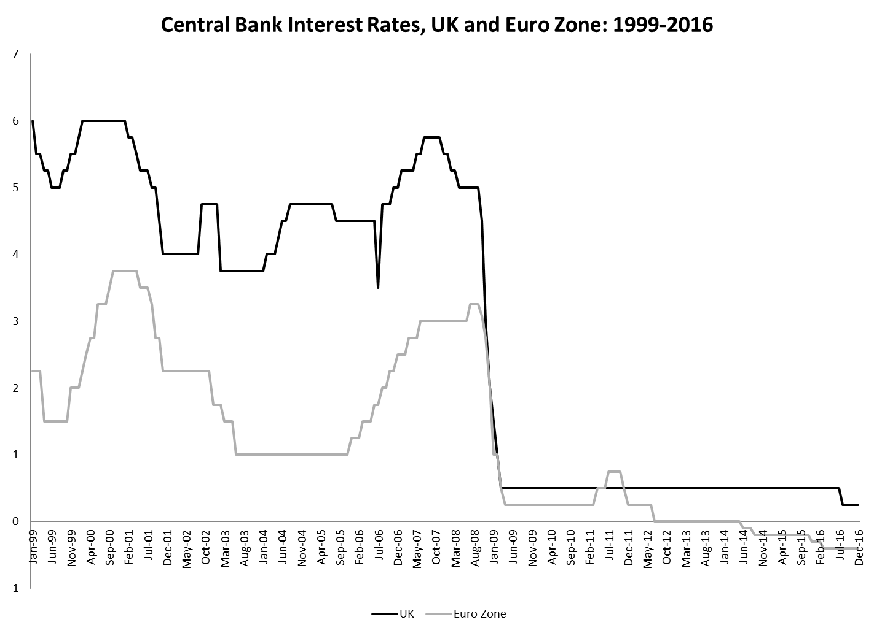
Had the United Kingdom been part of the euro area, it would have shared monetary policy with the other countries. On the one hand, this would have meant interest rates were perhaps too low for the United Kingdom, accelerating growth there and likely pushing inflation outside the 2% target range the United Kingdom prefers. At the same time, adding the United Kingdom to the euro area would have meant that the average growth rate and inflation rate in the euro area was higher. This may have led the ECB to a higher interest rate, which would have been inappropriate for countries like Germany who were experiencing slow growth and low inflation at this time. Interest rate differentials since 2009 have been much smaller, reflecting similar rates of inflation and real GDP growth in the United Kingdom and the euro zone. This suggests that since 2009, there would have been fewer chances for asymmetric effects of monetary policy had the United Kingdom adopted the euro. This comes with the caveat that unemployment rates across the euro zone have remained consistently higher than those in the United Kingdom over this period.
11. When the euro appreciated against China’s currency in 2007, EU countries that compete with China in third country export markets should have seen a larger drop in aggregate demand as various customers may have switched to the suddenly relatively cheaper Chinese products. Germany should be hurt less than Greece given the assumptions in the question. If Greece had its own currency, it may have allowed its currency to depreciate against Germany slightly so that it had a smaller appreciation against China. This may have mitigated the effects on its exporters.
12. Much like the concern that individual country governments would borrow too much and put pressure on the ECB to print too much money, an excessive CA deficit of an individual country may signal excessive borrowing in that country and could signal a future need for bailouts by the monetary authority. In addition, though, excessive CA deficits at the local country level with EMU may signal that the euro is heavily appreciated against the particular countries’ major trading partners or that monetary policy has created an excessive spending or investment boom in a country. Either is a symptom that a single monetary policy may be problematic for these countries.
13. All of these countries experienced significant increases in their current account balances (though the increase in Italy has been more modest than the other nations.) This is not surprising, as each of these countries suffered large economic downturns during the 2007–2009 financial crisis. As income in a country falls, consumers will buy fewer imports, causing the current account to rise. This trend is amplified by the austerity reforms that many of these countries made as a condition of receiving financial assistance during the crisis.
14. If a country had an “escape clause” and could readily leave the Eurozone, the currency stability offered by a monetary union is weakened. If the ECB signals that it will no longer act as a lender of last resort to that country’s banks, loans to that country will become riskier. Combine these two results and we see that the country would become a significantly larger credit risk. As capital fled the country, it is very likely that the nation would choose to exercise its escape clause and leave the Eurozone. Doing so would give it some control over its own monetary policy and allow its currency to depreciate, mitigating some of the losses from the massive capital outflow.
15. A condition of the bailout package to Cyprus was that some bank deposits in Cypriot banks would essentially be taxed to help pay for the financial support. To make this tax binding, the government had to impose a restriction on capital leaving the country or else depositors in Cypriot banks would have taken their money out to avoid this tax.
On another level, this requirement goes back to the open economy trilemma, the observation that you can never have all three of the following: fixed exchange rates, independent monetary policy, and capital mobility. The differential effects of the financial crisis across the Eurozone created a situation in which interest rates varied across countries, essentially breaking the common monetary policy of the currency union. As a result, the ECB had to decide upon maintaining currency stability or capital mobility. In the case of Cyprus, they chose to preserve currency stability by limiting capital mobility.
16. a. A fiscal expansion in Germany would shift the euro area DD curve to the right. If this is a permanent fiscal expansion, then the change in the expected exchange rate will also shift the AA curve down, reflecting the asset market clearing at an appreciated value of the euro. In the end, output remains unchanged and the euro gets stronger against other currencies. The effects on the other euro zone countries will depend on how much trade they have with countries outside the euro zone. The more trade they have, the stronger the negative effects of the appreciated euro on output and prices.
If the fiscal expansion is temporary, only the DD curve will shift to the right. This will still lead to an appreciation of the euro as higher output increases money demand and interest rates, but this will be temporary. Assuming the euro zone started at full employment before the fiscal expansion, then the increase in government spending will eventually be offset by higher prices across the euro zone.
b. If the euro zone is in a liquidity trap, then it is possible that a temporary fiscal expansion could get output back up to full employment if the region is initially along the flat portion of the AA curve. However, a permanent fiscal expansion will also shift the AA curve down because of the expected appreciation of the euro. This could exacerbate the liquidity trap.

